Week8_Setup your machine with Git Configuration (GitDemo)

Objective:
- To create a new repository, signup with GitLab and register your credentials
- Login to GitLab and create a “GitDemo” project.

Phase 1: Initial Git Configuration
Step 1: Verified Git Version
git version
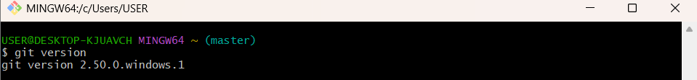
Step 2: Set Your User Name: This name will be associated with your commits.
git config --global user.name https://github.com/SaguturuShruthi
Step 3: Set Your User Name: This email will be linked to your commits.
git config --global user.email krishnashruthi2004@gmail.com
Step 4: Configured User Information
git config --global --list

Phase 2: Environment Setup: Integrating Notepad++
Step 5: Confirmed notepad++ Command Not Found Error
Step 6: Added Notepad++ to Environment Path
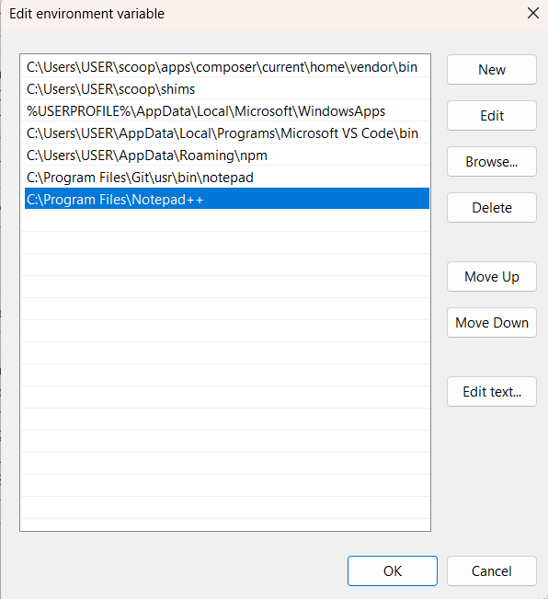
Step 7: Set Notepad++ as Git's Core Editor
git config --global core.editor "notepad++.exe -multiInst -nosession"

Step 8: Verify the Editor Configuration: To confirm the setup, run this command.
git config --global -e
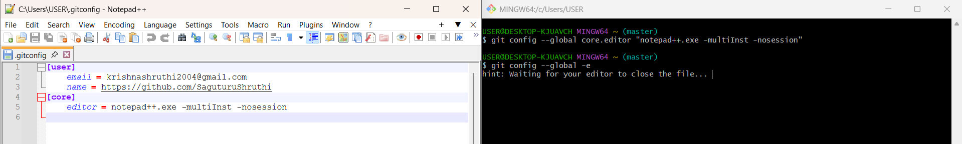

Phase 3: Local Repository Management
Step 9: Create a Project Directory:
- First, create a new folder for your project. For this guide, we will name it GitDemo. You can create this folder using Windows Explorer or via the command line.
- Navigate into this new directory using Git.
Step 10: New Git repository: Initialize a new Git repository in this directory.
git init
Step 11: Verify Repository: To see the hidden .git directory that was just created, run:
ls -al

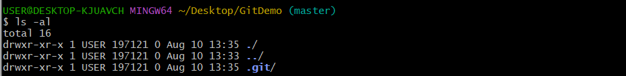
Step 12: Create a File: Create a new file named welcome.txt with some content.
echo "Welcome to the version control" >> welcome.txt
Step 13: Staged File: Checked status showing untracked file.
git status
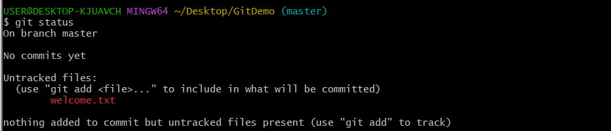
Step 14: Add File: Added file to staging.
git add welcome.txt
Step 15: Commit File: Commit the staged file to the local repository's history.
git commit
- This will automatically open Notepad++. Type a descriptive commit message on the first line, such as Initial commit: Add welcome.txt.
- Save the file and close Notepad++ to complete the commit.

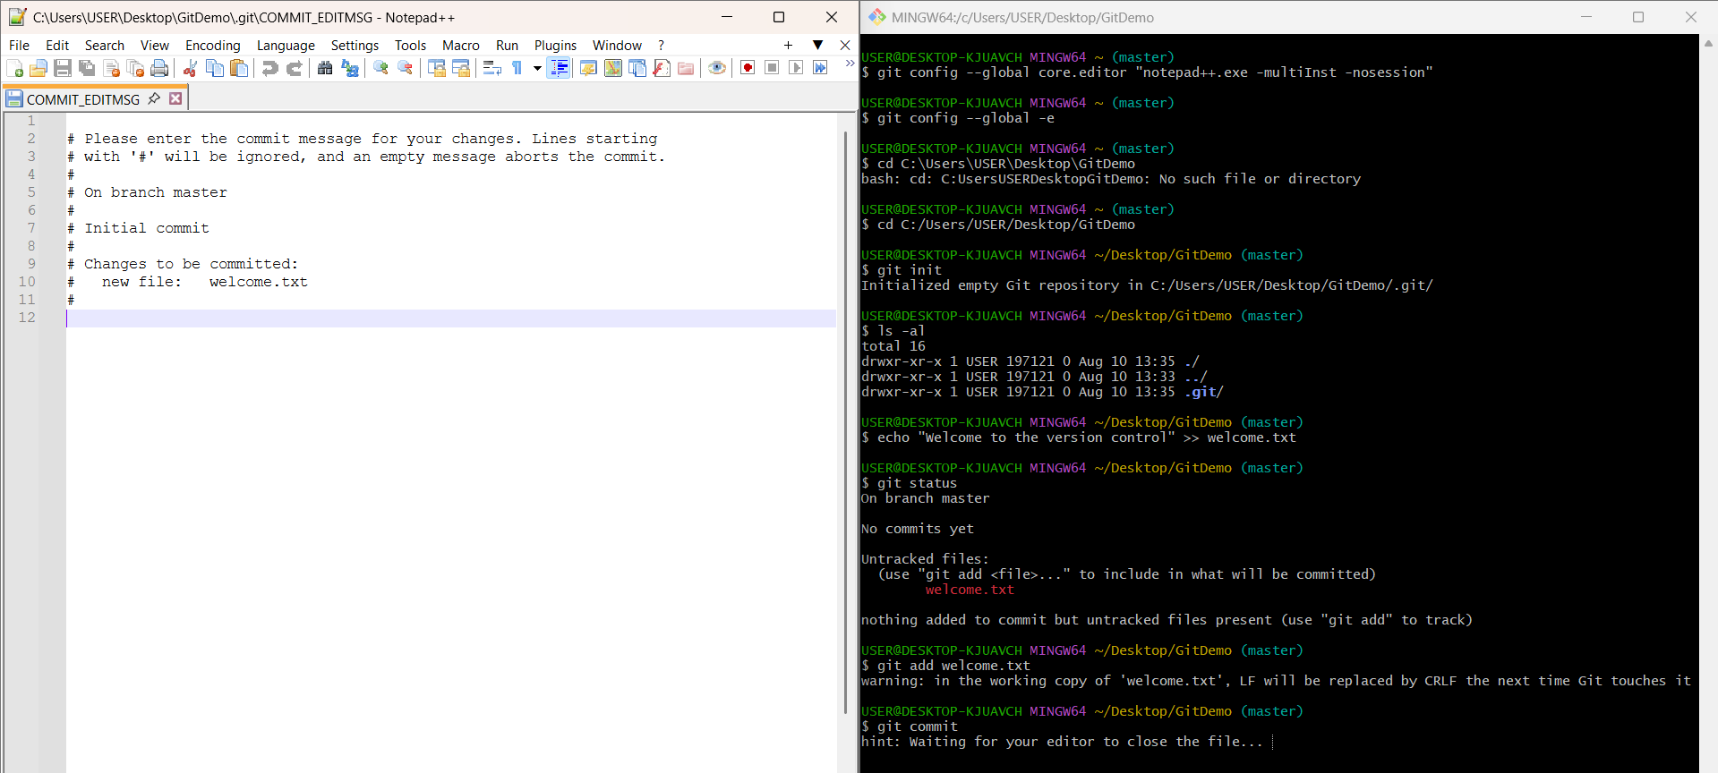

Phase 4: GitHub Remote Repository Integration
Step 16: Created Remote Repository:
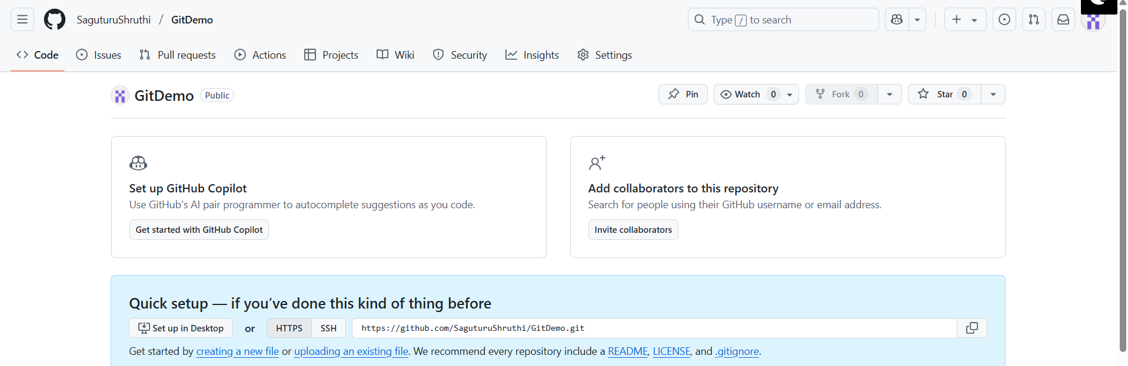
Step 17: Pushed Local Commits to Remote:
git push origin master
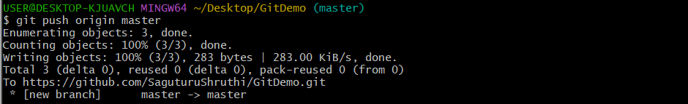
Step 18: Final Verification:
